//WAP to implement a class called circle that has private member variable for radius. Include member functions to calculate the circle's area and circumference. Also include another member function to display result.
21).

#include<iostream>
#include<cmath>
using namespace std;

class Circle {
private:
float rad, area, circ;
public:
void setdata(float r){
rad = r;
}
void Area(){
area = M_PI *rad*rad;
}
void circumference(){
circ = 2*M_PI*rad;
}
void display(){
cout<<"The area of circle ="<<area<<endl;
cout<<"The circumference of circle ="<<circ<<endl;
}
};
int main () {
int r;
cout<<"Enter the radius of the circle: "<<endl;
cin>>r;
Circle r1;
r1.setdata(r);
r1.Area();
r1.circumference();
r1.display();
return 0;
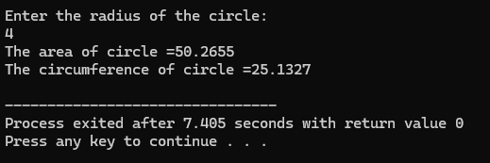
}
- Output:

//WAP to create class called Person that has private member variables for name, age, and country. Implement member function to set and display values of these variables.
22).
#include<iostream>
#include<string>
using namespace std;

class Person {
private:
string name;
int age;
string country;
public:
void setdata() {
cout << "Enter the name of person: ";
getline(cin, name);
cout << "Enter the age: ";
cin >> age;
cin.ignore();
cout << "Enter the person's country: ";
getline(cin, country);
}
void Display() {
cout << "\nPerson details:\n";
cout << "Name : " << name << endl;
cout << "Age : " << age << endl;
cout << "Country : " << country << endl;
}
};
int main() {
Person d;
d.setdata();
d.Display();
return 0;
}
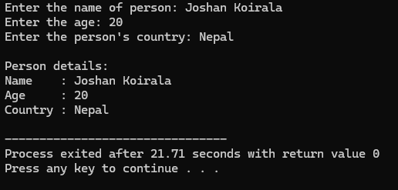
- Output:

// Create a class called car that has data members company, model and year. Implement member functions to get and display values.
23).
// Define member functions outside class.

#include<iostream>
using namespace std;

class Car{
private:
string company;
int model;
int year;
public:
void get ();
void display ();
};
void Car::get(){
cout<<"Enter the name of car company :";
getline(cin, company);
cout<<"Enter the car Model number : ";
cin>>model;
cout<<"Enter the manufacture year :";
cin>>year;
}
void Car::display(){
cout<<"\n Car details:\n";
cout<<"Company name : "<<company<<endl;
cout<<"Model : "<<model<<endl;
cout<<"Year : "<<year<<endl;
}
int main() {
Car c;
c.get();
c.display();
return 0;
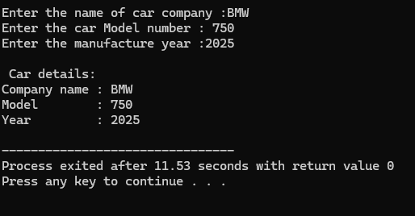
}
- Output:

// WAP to create a class named BankAccount with private data member account_number and balance. Implement member functions to deposit and withdrawal money from the account. Also create member function to display balance.
24).
// [Need to check whether there is sufficient balance or not while withdrawal].

#include <iostream>
using namespace std;

class BankAccount {
private:
long long int account_number;
double balance;
public:
void setAccount(long long int no, double initial) {
account_number = no;
balance = initial;
}

void deposit(double amount) {
if (amount > 0) {
balance += amount;
cout << "Deposited: " << amount << endl;
}
else {
cout << "Invalid deposit amount!" << endl;
}
}

void withdraw(double amount) {
if (amount > balance) {
cout << "Insufficient balance. Withdrawal failed!" << endl;
}
else if (amount <= 0) {
cout << "Invalid withdrawal amount!" << endl;
}
else {
balance -= amount;
cout << "Withdrawn: " << amount << endl;
}
}

void displayBalance() {
cout << "Account Number: " << account_number << endl;
cout << "Current Balance: " << balance << endl;
}
};

int main() {
BankAccount acc;
long long int acc_no;
double initial, dep, wd;

cout << "Enter account number: ";
cin >> acc_no;
cout << "Enter initial balance: ";
cin >> initial;

acc.setAccount(acc_no, initial);

cout << "\n--- Deposit ---\nEnter amount to deposit: ";
cin >> dep;
acc.deposit(dep);

cout << "\n--- Withdrawal ---\nEnter amount to withdraw: ";
cin >> wd;
acc.withdraw(wd);

cout << "\n--- Account Summary ---" << endl;
acc.displayBalance();

return 0;
}
- Output:
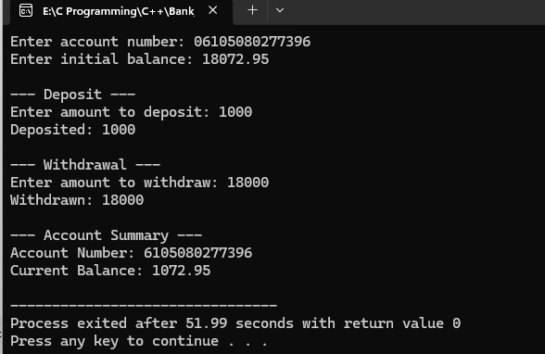

// Demonstrate a class Sale that calculate the sale on an overall items, where sales is 6% on overall items. You must call a constructor that takes the sale rate as an argument and two-member function getTotal which returns total sale. Your program should print the TotalSale in main function.
25).
#include <iostream>
using namespace std;
class Sale {
private:
float saleRate;
float totalAmount;
public:
Sale(float rate) {
saleRate = rate;
totalAmount = 0;
}
void inputItems(int numItems) {
float price;
for (int i = 1; i <= numItems; i++) {
cout << "Enter price of item " << i << ": ";
cin >> price;
totalAmount += price;
}
}
float getTotal() {
return totalAmount + (totalAmount * saleRate);
}
};
int main() {
int n;
cout << "Enter number of items: ";
cin >> n;
Sale s(0.06);
s.inputItems(n);
float totalSale = s.getTotal();
cout << "\nTotal Sale (including 6%): " << totalSale << endl;
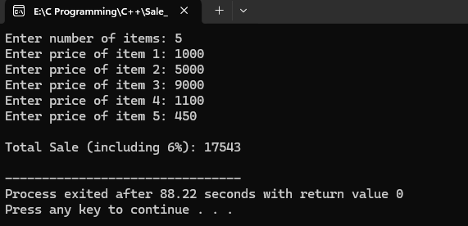
return 0;
}
- Output:

// Create a class 'Employee' having two private data members EmployeeName and EmployeeId. Create an object 'Employee1' of type Employee. Copy contents of Employee1 to Employee2.
26).
// [Both Shallow and Deep copy]
#include <iostream>
using namespace std;

class Employee {
private:
string EmployeeName;
int EmployeeId;
public:
Employee() {
EmployeeName = "";
EmployeeId = 0;
}
Employee(string name, int id) {
EmployeeName = name;
EmployeeId = id;
}
// Deep Copy Constructor
Employee(Employee& e) {
EmployeeName = e.EmployeeName;
EmployeeId = e.EmployeeId;
}
// Shallow copy
void shallowCopy(Employee& e) {
EmployeeName = e.EmployeeName;
EmployeeId = e.EmployeeId;
}
void display() {
cout << "Employee ID: " << EmployeeId << ", Name: " << EmployeeName << endl;
}
};
int main() {
Employee Employee1("Joshan", 9);

// Deep Copy
Employee Employee2 = Employee1;

// Shallow Copy
Employee Employee3;
Employee3.shallowCopy(Employee1);

cout << "\nOriginal (Employee1): ";
Employee1.display();

cout << "Deep Copy (Employee2): ";
Employee2.display();

cout << "Shallow Copy (Employee3): ";
Employee3.display();

return 0;
}
- Output:
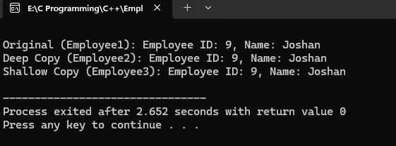
WAP showing Constructor overloading with appropriate example
#include <iostream>
using namespace std;

class Number {
private:
int value;
public:
Number() {
value = 0;
}
Number(int x) {
value = x;
}
void display() {
cout << "Value: " << value << endl;
}
};
int main() {
Number n1;
Number n2(100);
n1.display();
n2.display();
return 0;
}
- Output:
27).
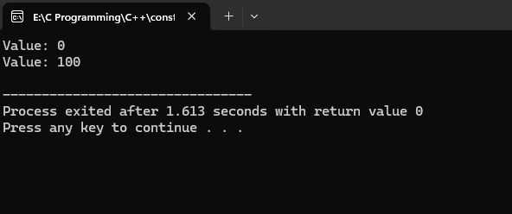

// WAP showing concept of Destructor
28).

#include <iostream>
using namespace std;

class Demo {
public:
Demo() {
cout << "Constructor called!" << endl;
}

~Demo() {
cout << "Destructor called!" << endl;
}

void show() {
cout << "Inside show() function." << endl;
}
};

int main() {
Demo d1;
d1.show();
return 0;
}
- Output:
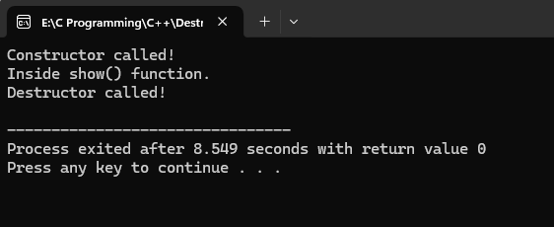

WAP to implement static data member and static data function. Each time object is instantiated, the constructor increases the static count. A static function getcount() is used to acess the count. Call static function without object and dot operator.
29).
#include <iostream>
using namespace std;

class Sample {
private:
static int count;
public:
Sample() {
count++;
}
static void getCount() {
cout << "Total objects created: " << count << endl;
}
};
int Sample::count = 0;
int main() {
Sample s1;
Sample s2;
Sample s3;
Sample::getCount();
return 0;
}
- Output:
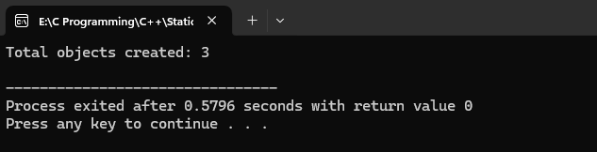
The interest rate is static member common to all bank accounts. It can be changed via static function. Each object can calculate its owm interest using shared interest rate.
30).
#include <iostream>
using namespace std;

class Interest {
private:
double balance;
int time;
static float rate;
public:
void input() {
cout << "Enter balance: ";
cin >> balance;
cout << "Enter time (in years): ";
cin >> time;
}
void calculate() {
double interest = (balance * rate * time) / 100;
cout << "Balance: " << balance << endl;
cout << "Time: " << time << " years" << endl;
cout << "Interest: " << interest << endl;
}

static void setRate(float r) {
rate = r;
}
};

float Interest::rate = 5.0;

int main() {
char change;
float newRate;

cout << "Default interest rate is 5%\n";
cout << "Do you want to change the interest rate? (y/n): ";
cin >> change;

if (change == 'y' || change == 'Y') {
cout << "Enter new interest rate: ";
cin >> newRate;
Interest::setRate(newRate);
}

Interest i1;
i1.input();
i1.calculate();
return 0;
}
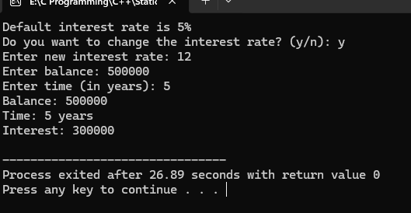
- Output:1
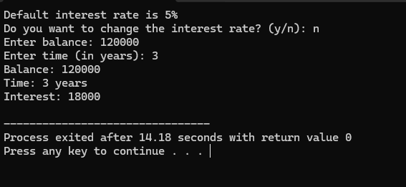

- Output:2

// WAP to demonstrate passing an object to function by
31).
//a). Value
//b). Reference
//c). Pointer

#include <iostream>
using namespace std;

class Sample {
private:
int data;
public:
Sample(int d) {
data = d;
}
void show() {
cout << "Data = " << data << endl;
}
void setData(int d) {
data = d;
}
int getData() {
return data;
}
};
// Pass by Value
void passByValue(Sample obj) {
obj.setData(100);
cout << "Inside passByValue(): ";
obj.show();
}

// Pass by Reference
void passByReference(Sample &obj) {
obj.setData(200);
cout << "Inside passByReference(): ";
obj.show();
}

// Pass by Pointer
void passByPointer(Sample *obj) {
obj->setData(300);
cout << "Inside passByPointer(): ";
obj->show();
}

int main() {
Sample s(10);

cout << "Original Object: ";
s.show();
cout << "----------------------------" << endl;
passByValue(s);
cout << "After passByValue(): ";
s.show();
cout << "-----------------------------" << endl;
passByReference(s);
cout << "After passByReference(): ";
s.show();
cout << "-----------------------------" << endl;
passByPointer(&s);
cout << "After passByPointer(): ";
s.show();
return 0;
}

- Output:
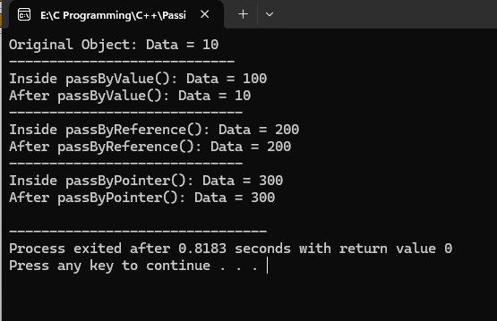
// WAP demonstrate returning an object to function by
32).
//a). Value
//b). Reference
//c). Pointer

#include <iostream>
using namespace std;

class Sample {
private:
int data;
public:
Sample(int d = 0) {
data = d;
}

void setData(int d) {
data = d;
}
void show() {
cout << "Data = " << data << endl;
cout << "----------------------------" << endl;
}

int getData() {
return data;
}
};
// a) Return by Value
Sample returnByValue() {
Sample obj(100);
return obj;
}

// b) Return by Reference
Sample& returnByReference() {
static Sample obj(200);
return obj;
}

// c) Return by Pointer
Sample* returnByPointer() {
static Sample obj(300);
return &obj;
}

int main() {
Sample a = returnByValue();
cout << "Returned by Value: ";
a.show();

Sample& b = returnByReference();
cout << "Returned by Reference: ";
b.show();

Sample* c = returnByPointer();
cout << "Returned by Pointer: ";
c->show();
return 0;
}
- Output:
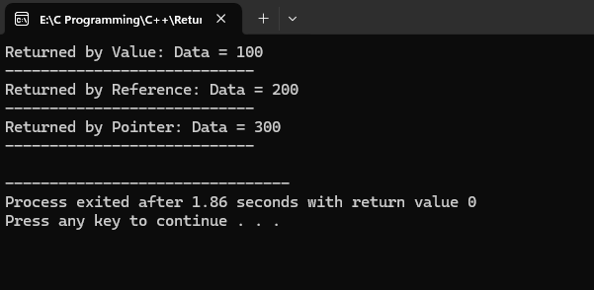

// WAP to design a class complex to represent complex numbers. Write a function sum(friend) to add two complex numbers. The function should return an object of type complex representing sum of two complex numbers.
33).
#include<iostream>
using namespace std;

class complex
{
int real, image;
public:
friend complex sum(complex a,complex b);
void show()
{
cout<<real<<"+"<<image<<"i"<<endl;
}
void get()
{
cout<<"Enter the real number:";
cin>>real;
cout<<"Enter the imaginary number:";
cin>>image;
}
};
complex sum (complex a,complex b)
{
complex temp;
temp.real=a.real+b.real;
temp.image=a.image+b.image;
return temp;
}

int main() {

complex c1;
complex c2;
cout << "Enter first Complex Number: "<<endl;
c1.get();
cout << "Enter second Complex Number: "<<endl;
c2.get();
cout << "\n First Complex Number:";
c1.show();
cout << "Second Complex Number:";
c2.show();
complex result = sum(c1, c2);
cout << "\n-------Sum of the Complex Numbers:";
result.show();

return 0;
}
- Output: -

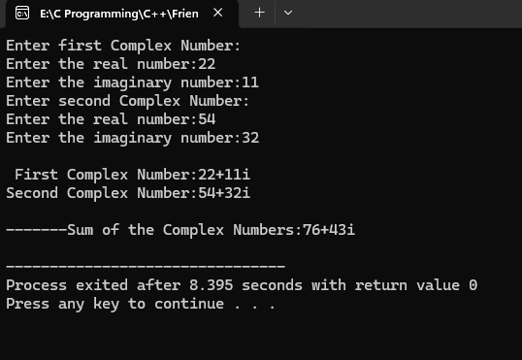

// WAP showing friend function as bridge between two class.
34).
#include <iostream>
using namespace std;

class B;
class A {
private:
int a;
public:
A (int val) {
a = val;
}
friend void showSum(A, B);
};
class B {
private:
int b;
public:
B (int val) {
b = val;
}
friend void showSum(A, B);
};
void showSum(A objA, B objB) {
cout << "Value of Class A: " << objA.a << endl;
cout << "Value of Class B: " << objB.b << endl;
cout << "Sum: " << objA.a + objB.b << endl;
}
int main() {

A objA(10);
B objB(20);
showSum(objA, objB);
return 0;
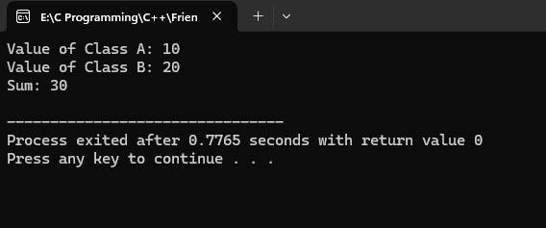
}
- Output: -

